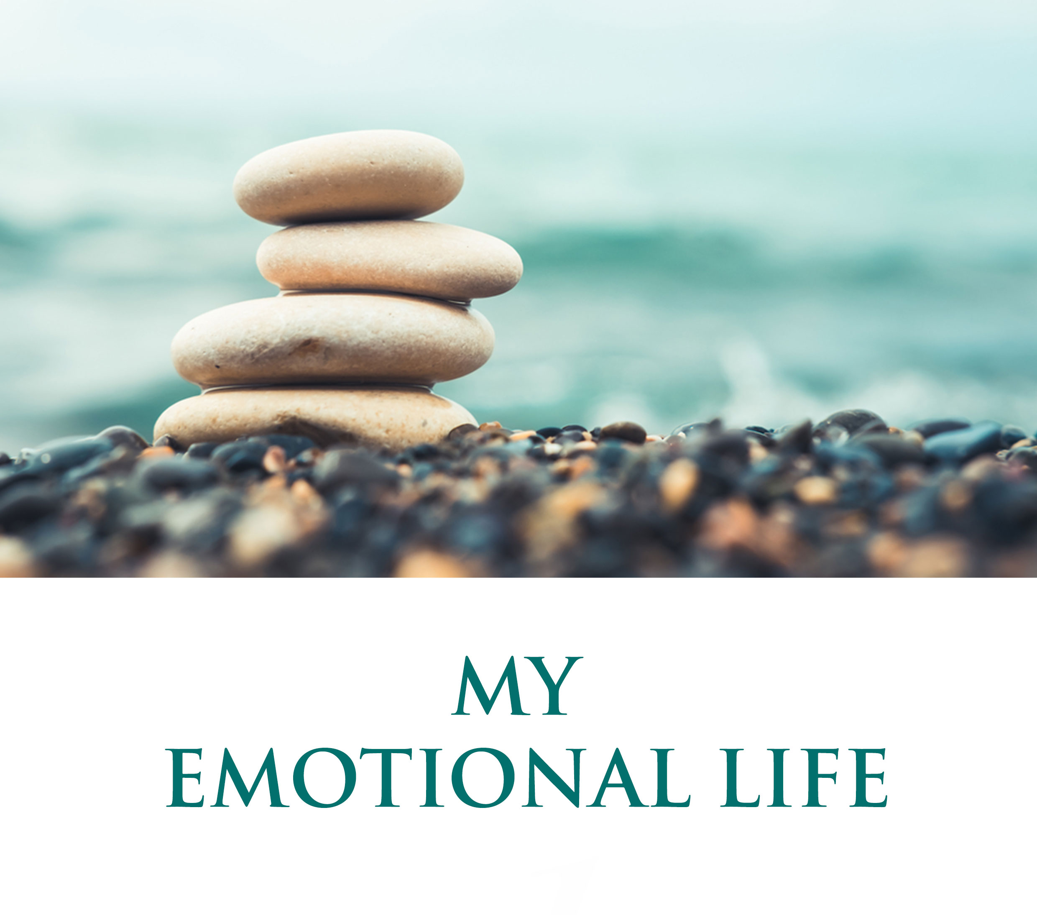

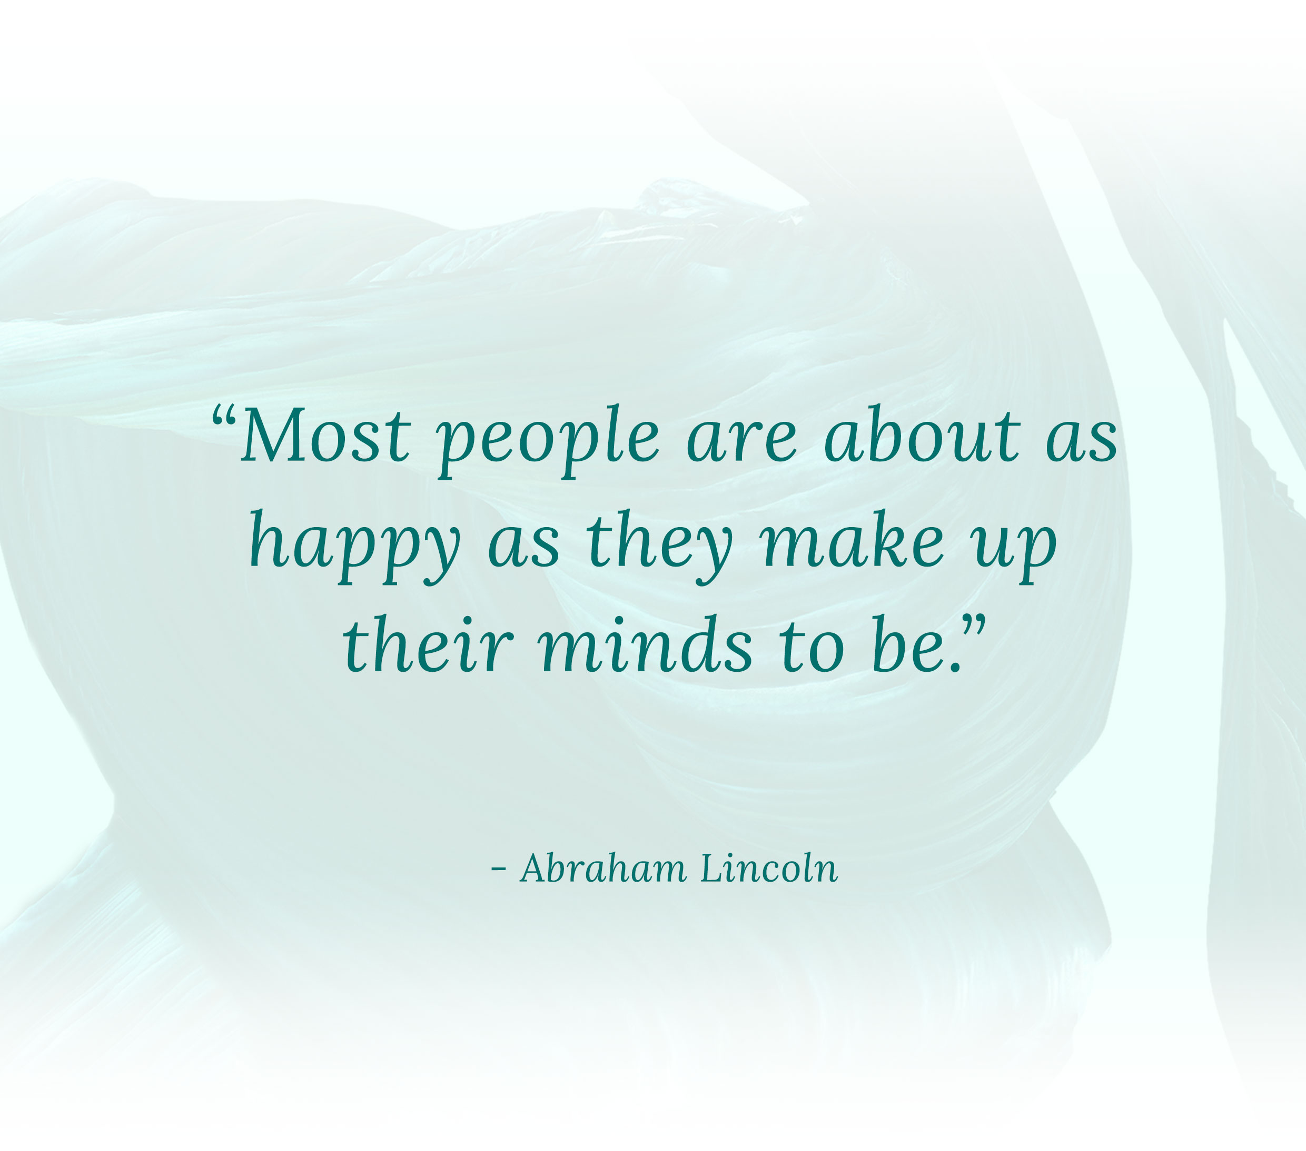

PREMISE
Your Premise refers to the foundational beliefs you hold about this category. What do you believe? What deeply held beliefs are shaping your life? Are your beliefs empowering? Do they move you at a deep level or are they holding you back? What is your Premise for this area of your life, or what would you like it to be?

The examples below are from Jon & Member Wisdom PREMISE statements. Keep them, modify them, or delete them all and replace them with something that truly appeals to you. Your choice. Your final page should have your unique mark.

- Achieving excellence in any dimension of life requires high emotional intelligence.
- Emotional intelligence is made up of 2 components. Emotional Insight + Emotional Control. Emotional Insight means being conscious of, accepting and learning from my emotions. Emotional control means the ability to create emotions I want in my life.
- My emotions are tools of awareness and consciousness - a window into my soul.
- My emotions are my guidance system. They help me understand cheater or not my thoughts are in alignment with who I really am.
- Happiness is something I decide on ahead of the time.
- My emotions are mine, to do with as I choose. When I am able to access my emotions, I am much more effective at making choices, decisions, and commitments.
- I believe wholeheartedly that my emotional life is my intuitive guidance from God.
- Nobody can create my happiness other than me.
- I am my own emotional master chef. I know all the recipes, even the secret sauces of my emotions.
- Mastering and maintaining emotional integrity is the key to mastering my life.

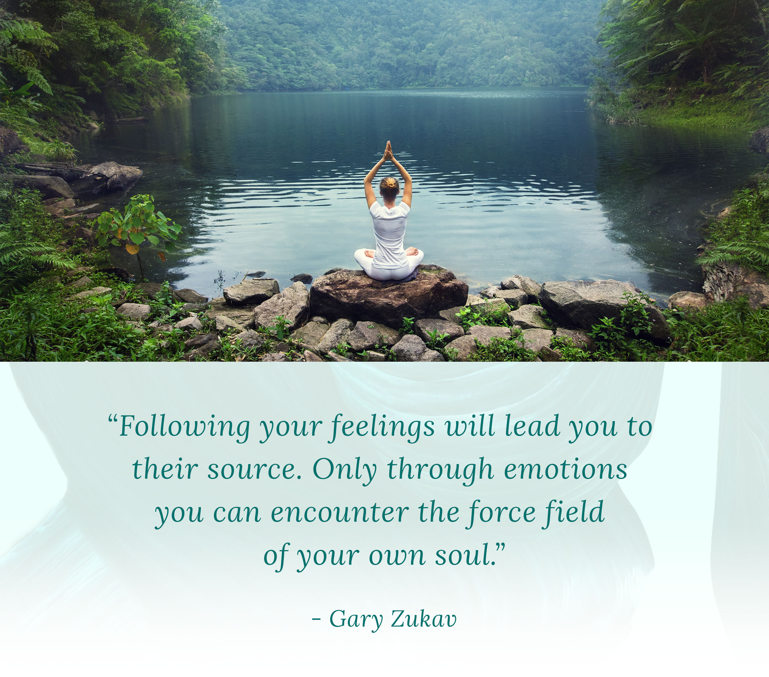

VISION
Your Vision refers to the ideal state you would like to achieve in this important category. Ask yourself: How do you want this area of your life to feel? What do you want it to look like? What do you want to be doing on a consistent basis? Clearly describe your ideal Vision.

The examples below are from Jon & Member Wisdom VISION statements. Keep them, modify them, or delete them all and start fresh. Your choice.

- I see myself as having very high emotional intelligence.
- I will become a master at managing my emotional states. I will define and create the emotional experiences I want to feel on an ongoing basis.
- I'll let all those positive emotions add up to an extraordinary attitude.
- I will consciously cultivate and nurture my highest emotional value - Happiness.
- My emotions empower my relationships and my actions. I radiate gratitude, kindness, compassion, sensuality, and balance.
- I will acknowledge and respect all my emotions, but I will guide and nurture those that most support the life I truly want to live.
- Joy and gratitude are my consistent and natural states.
- I will be positive and create tremendous joy and happiness in my life. i will forgive myself, trust myself, encourage myself, and live myself.
- I am a master of my emotional states and I will consciously create emotions of high-frequency vibrations.
- I can easily choose & control my emotions.
- I listen to and learn from my emotions and I integrate the gifts they give me, so I can move my life in a more expansive direction.
- I constantly listen to my emotions - not only to gain valuable insights but also to learn and take intelligent action.

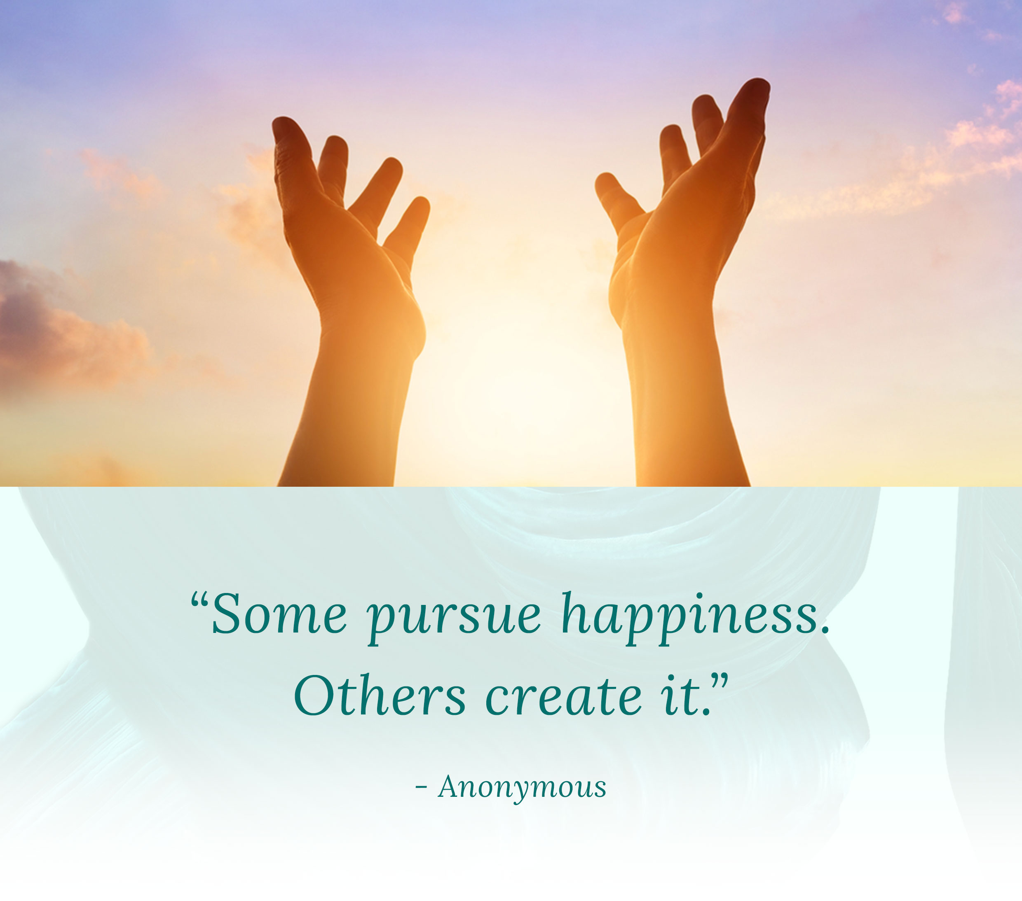

PURPOSE
Your Purpose refers to the compelling reasons behind what you want in this category. What energizes you? What empowers you to take action? What motivates you to achieve your Vision? Describe WHY you want to make the most out of this area of your life.

The examples below are from Jon & Member Wisdom PURPOSE statements. Keep them, modify them, or delete them all and start fresh. Your choice.

- Consistently great emotions equal a consistently great life.
- I believe that high emotional intelligence is mandatory for me to achieve my goals.
- I want to be an inspirational example to others.
- I will use my emotional states to live up to my full potential, to fully accept myself and learn from myself, to be happy and to have fun.
- Creating happiness, love, excitement, confidence, peacefulness, and compassion is the foundation of every success in my life.
- My purpose in controlling my emotions is to vibrate at a higher frequency and to set a great example for my children.
- I want to empower me.
- By developing more Emotional Intelligence, I am better able to relate with other people, because I will be relaxed, confident and happy with myself.
- I don’t want to be reactive. I want to have more time between action and reaction. I want to own my emotions, I don’t want my emotions to own me.
- I will be a better friend if I feel deeply, and better understand the feelings of those I love. I can make their lives more joyful, blessed and filled with love.
- The be-all, end-all purpose in life is happiness. Being happy is the whole point. It is the only real success.
- I want to own my emotions, I don't want my emotions to own me.

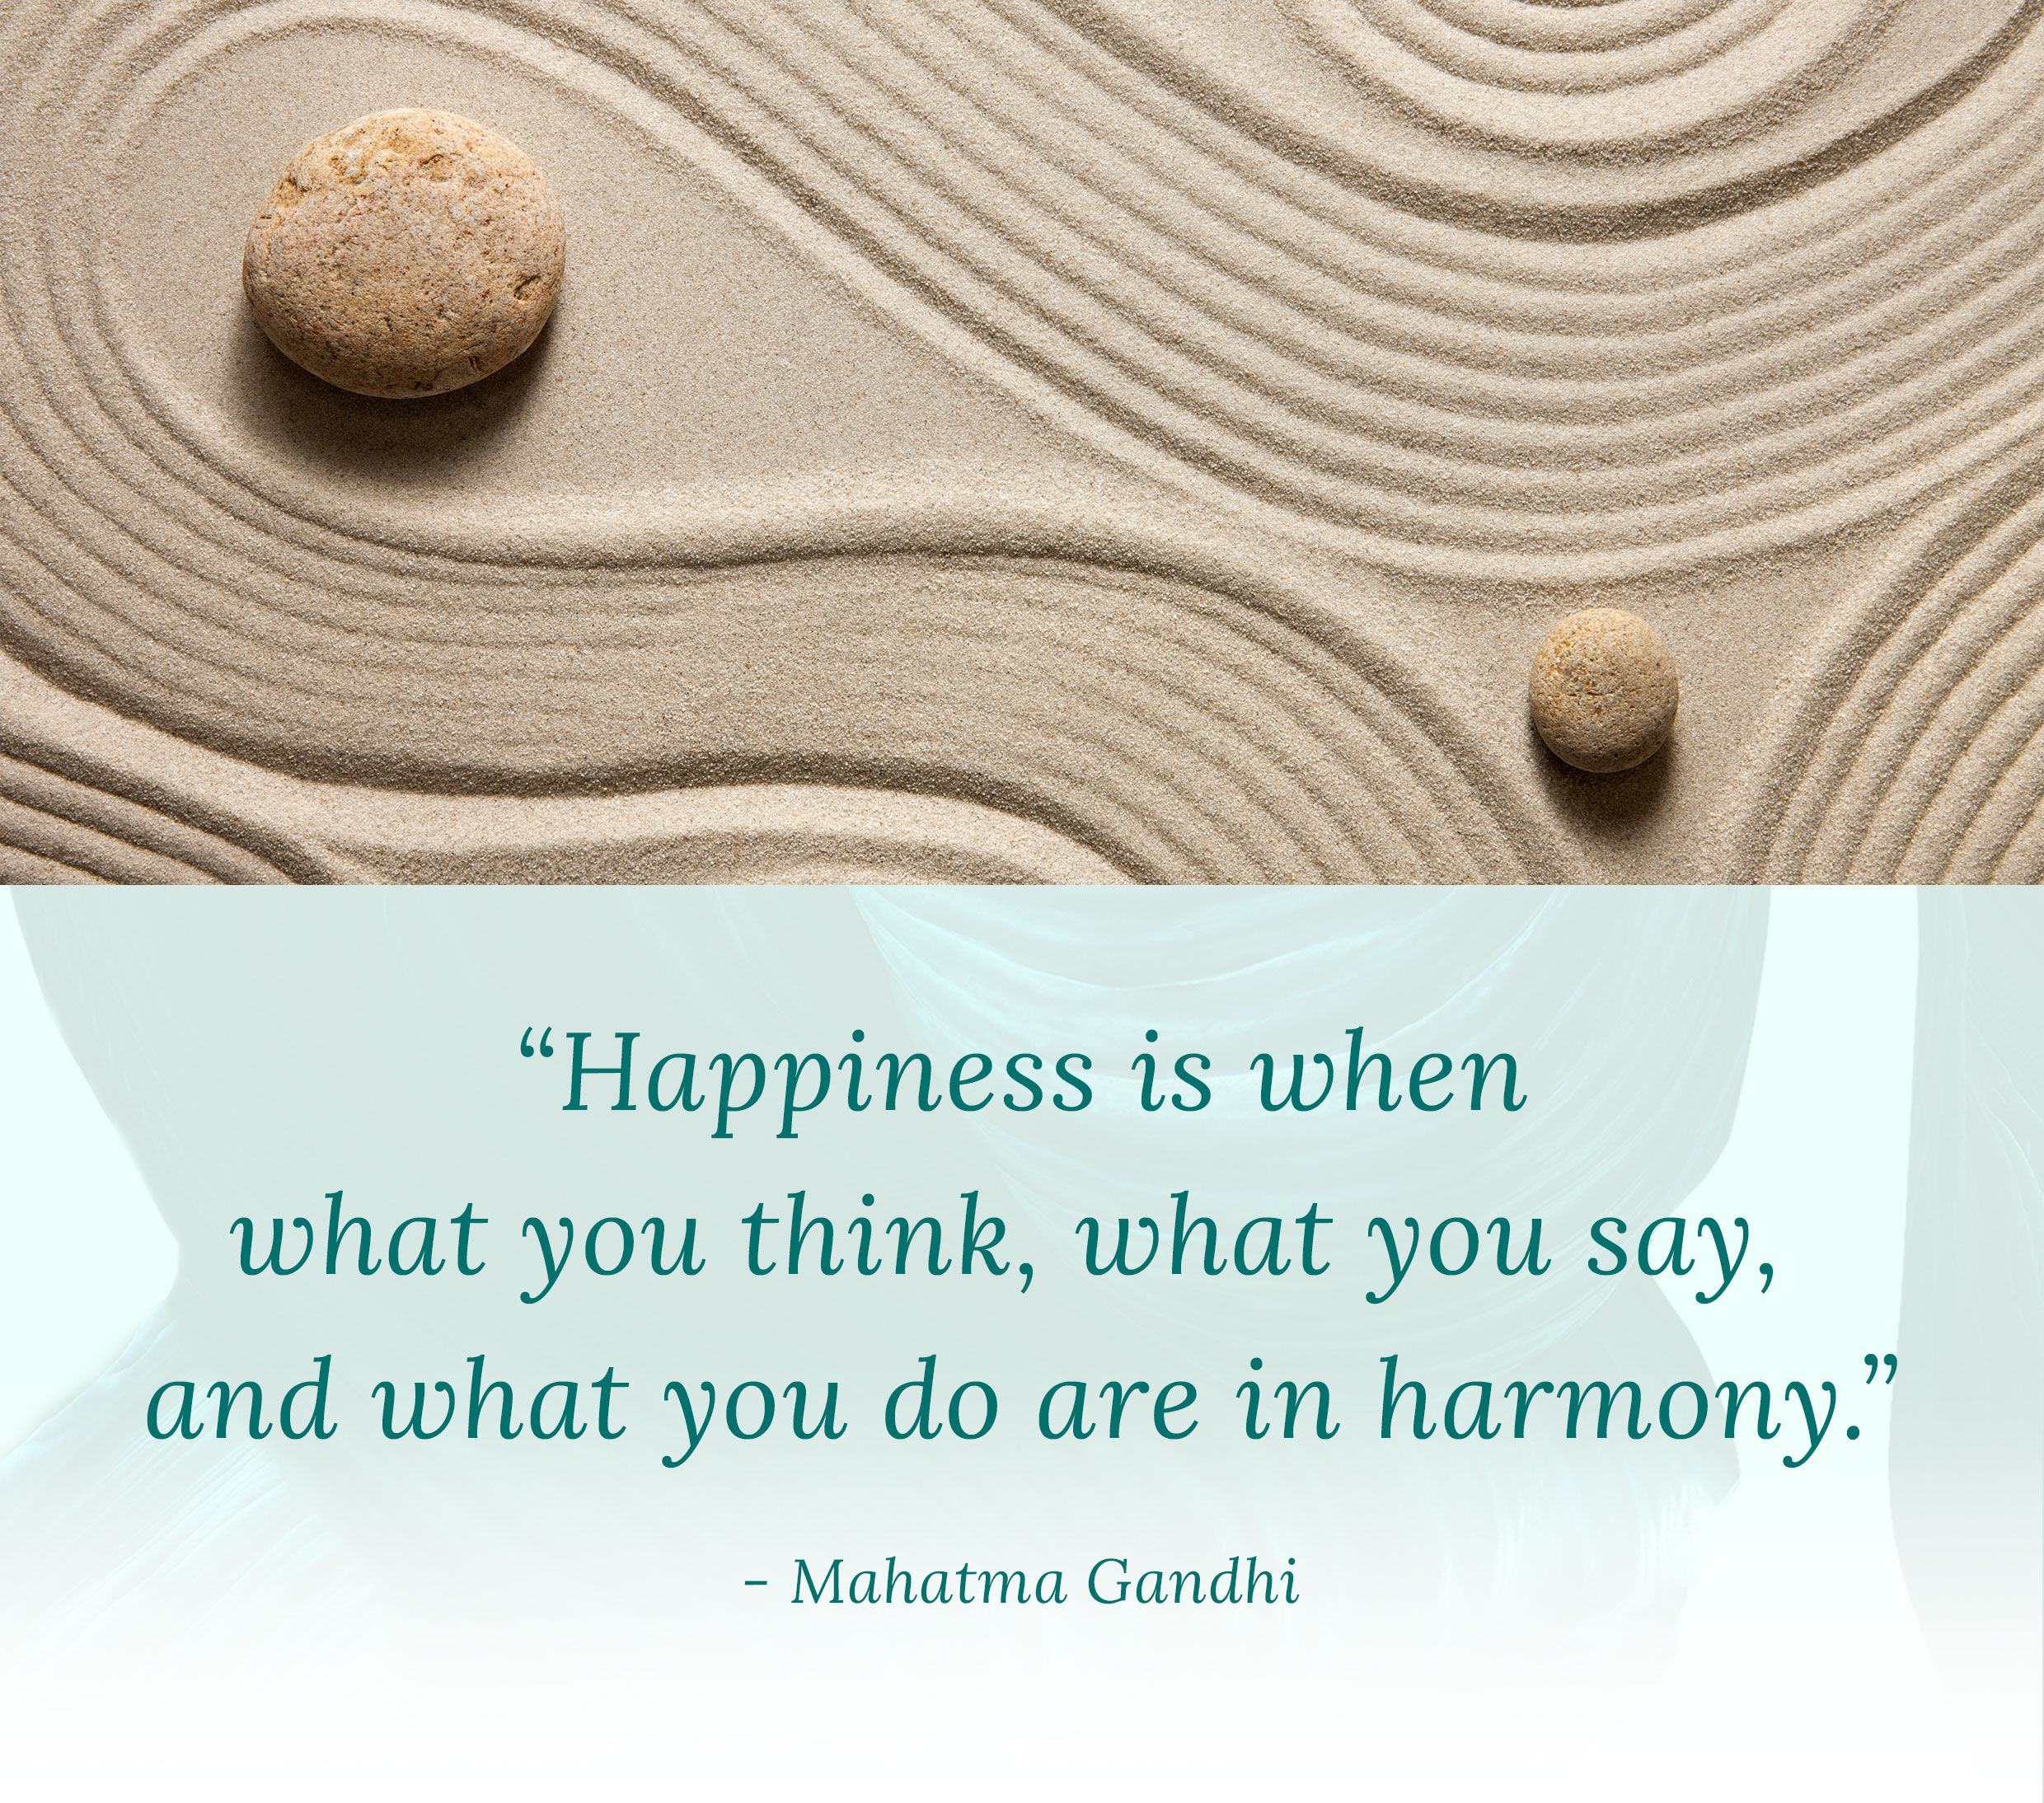

STRATEGY
Your Strategy refers to the specific actions that will get you from where you are now to where you want to be. How will you bring your vision into reality? Ask yourself what kind of positive habits, attitudes and action steps you can implement. What’s the RECIPE for the Vision you want to create?

The examples below are from Jon & Member Wisdom STRATEGY statements. Keep them, modify them, or delete them all and start fresh. Your choice.

- Key strategy. 1. Pay attention to what makes you happy vs. what makes you unhappy on a consistent basis. 2. Define your "recipe" for the moments and situations that make you happy, plan and add more of these types of movement to your life. 3. Define the "recipe" that leads to recurring pain & frustration for you. Find out how they show up in your life and avoid, limit or eliminate those situations.
- I will release negative emotional states and replace them with positive affirmations, especially chosen for my personality type.
- I will learn to meditate and take time to be grounded, so I can create more compassion and empathy in my life.
- I will use positive past memories to program desirable emotional states and override negative behavior patterns.
- I will begin each day as the best version of me that I can be. I will focus on taking action towards at least 3 positive emotions each day.
- I will experience, smile, embrace and move forward with more love and understanding for myself and others.
- I will give thanks and experience gratitude daily. I will journal to release trapped negative energy. I will say I love you and I’m sorry whenever they need to be said.

